GRADE 1. WEEK 35
ANSWER: END OF YEAR TEST

1.Listen: ( Mở file nghe đính kèm - Track 14)
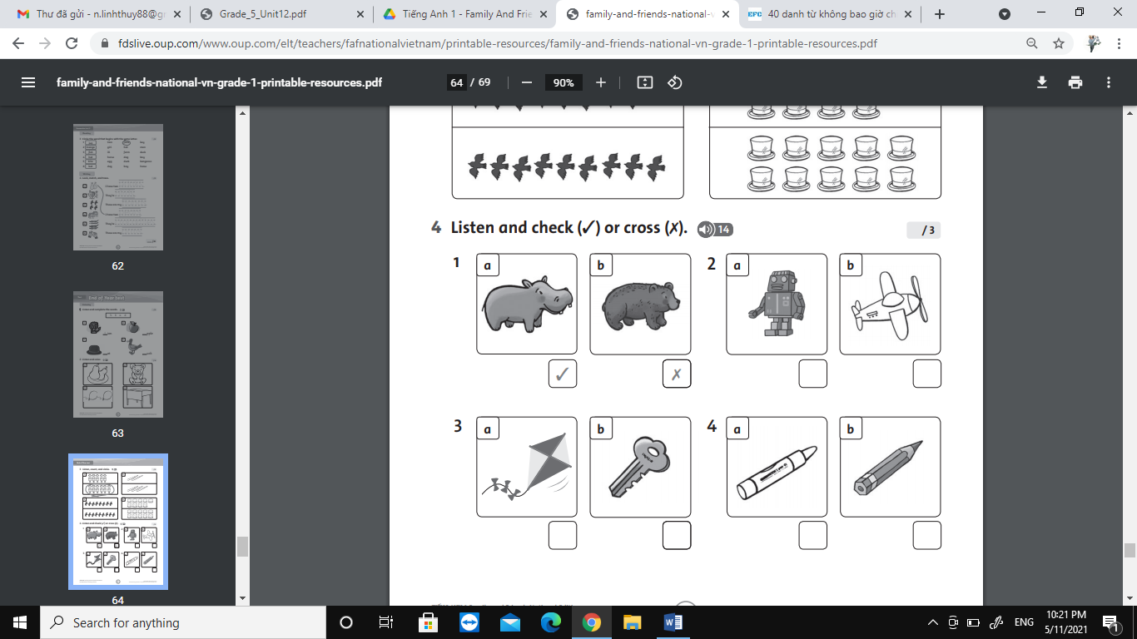
2.
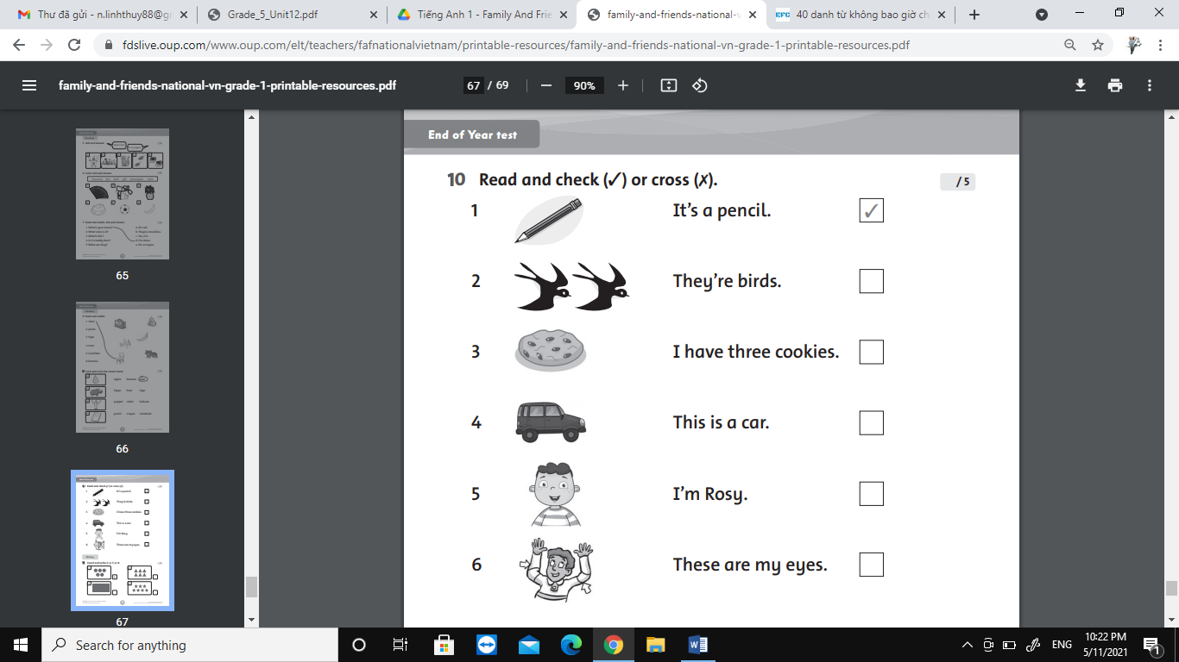
3. Read and color:
1. These are yellow pears. 2. This is a brown teadybear.
3. these are red balloons. 4. This is a blue desk.
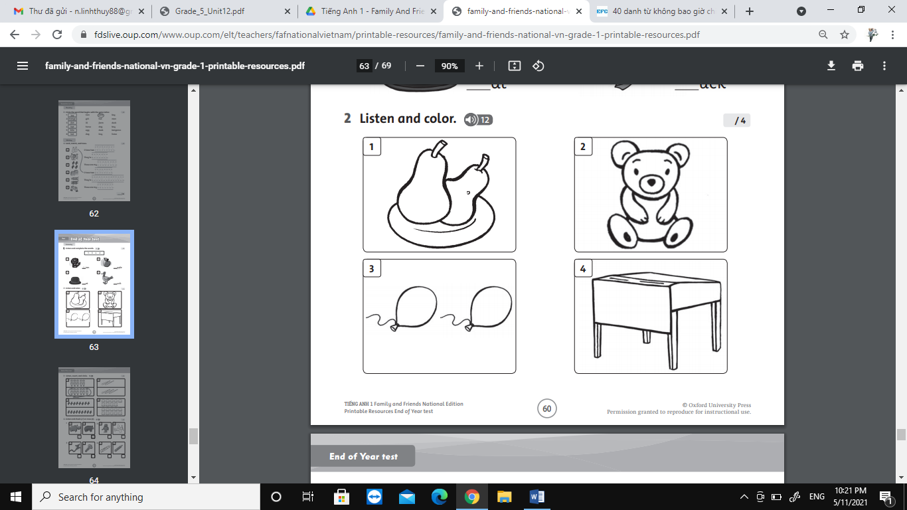

4.
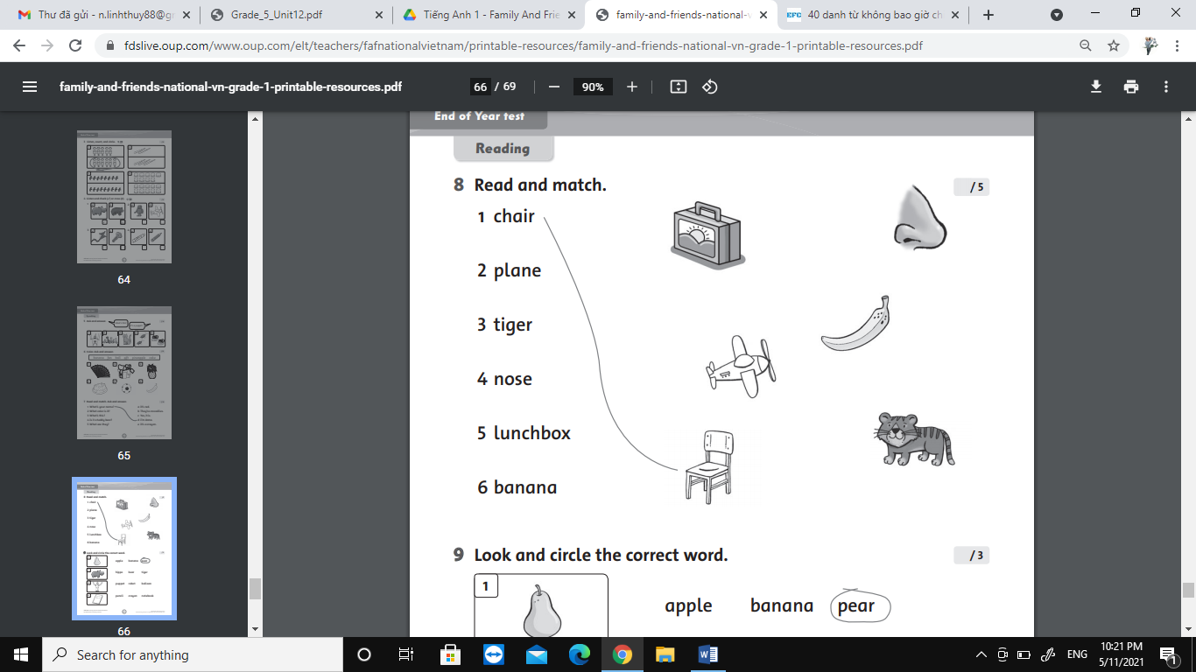
5..
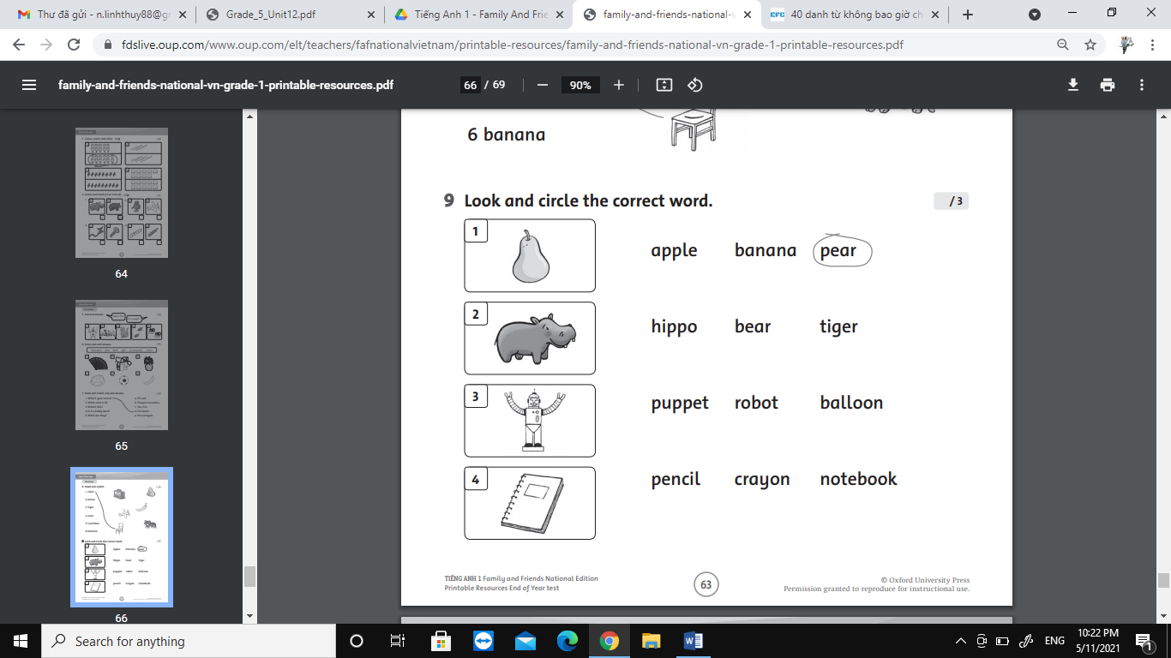

6.
